**Formula 1**

Stakeholder Interview - Kaloyan Rakov

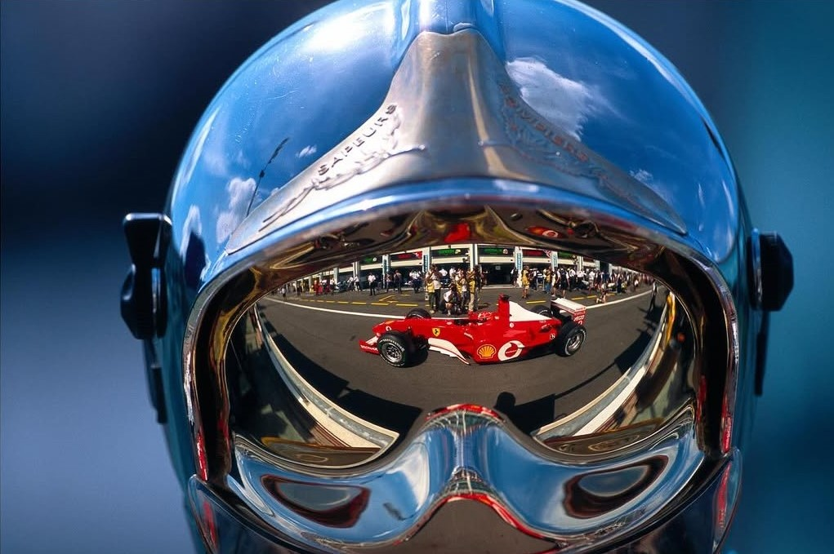

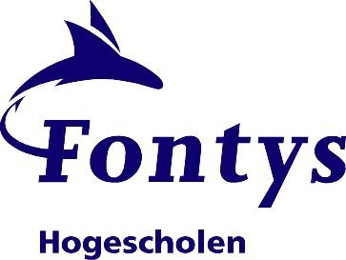

Stakeholder: Maxim Stefanov

Lifelong Formula 1 Fan, Engineering Student and Sofia Regional Karting Champion.

**Questions:**

**Do you find the project/model helpful for Formula 1 analysis?**

Yeah, I think the model is a good starting point. It helps show patterns between teams and drivers based on their past performances, which is useful when you're trying to make sense of a lot of stats. It’s not perfect, but it’s a solid foundation and pretty exciting if you're into sports analytics.

**How would you rate the accuracy?**

For experienced drivers, it’s fine, however for rookies the model can be quite inaccurate, since there isn’t as much data about them.

**Is there more data/details you would want to see?**

Absolutely. Adding more variables such as:

* Track type (street vs. permanent circuit)
* Weather conditions (rain, dry, etc)
* Tyre strategies
* Pit stop efficiency
* Driver form over recent races  
  (would provide a richer dataset and better predictive power).

**Could the model be used for strategy building?**

In a basic sense, yes — it could help simulate outcomes based on driver-team combinations and predict points scenarios. However, to be used for serious strategic planning (as teams do), it would need real-time data feeds, simulations based on race events (like safety cars or penalties), and more predictive variables. Still, this lays the foundation for those use cases.

**Could the project be used by different types of stakeholders?**

Yes:

* **Analysts** could use it to test hypotheses about performance trends.
* **Bookmakers** might explore it for odds generation, although it would need regulatory validation.
* **Team staff** could use it as a tool to present fan-friendly or PR-facing data, not necessarily internal decision-making.

**How much more in depth could the project go?**

Yes, a full-scale version could include:

* Lap-by-lap predictive modeling
* Driver behavior modeling (aggressiveness, overtaking patterns)

**Any updates on the dashboard?**

There’s room to enhance the UI/UX— adding live charts, driver profiles, season stats, comparison tools, and historical race visualizations. Making it dynamic and interactive would increase usability for fans and analysts alike.

**Could the project be used for service of the fans (personalisation)?**

Yes, this is a strong potential area. Features like:

* Personalized predictions based on a user's favorite team/driver,
* Notifications for upcoming races,
* Interactive simulations for fans to adjust variables (e.g., change a driver’s qualifying position and see how the prediction changes),  
  would make the app highly engaging and enhance fan experience.